Admission of Pupils
Admissions Policy
2027-2028
The number of pupils admitted in the last year was 60.
The agreed admissions limit for the annual intake of pupils is 60.
The number of pupils on roll in September 2025 was 468.
Pupils will be admitted without reference to ability or aptitude during the academic year that they reach the age of 5 years.

Our over subscription policy for the year starting 1st September 2026 is:
- The published admission number for Allington Primary School is 60. In accordance with legislation, where a child's Education Health and Care Plan (EHCP) names Allington Primary School as the most appropriate school, priority will be given to that child. Before the application of our oversubscription criteria, children with a statement of special educational need which names the school will be admitted. As a result of this, the published admissions number will be reduced accordingly.

Where there are more applications than the number of remaining places, pupils will be prioritised in accordance with the oversubscription criteria as set out below:

- Children in Local Authority Care or Previously in Local Authority Care – a 'looked after child' or a child who was previously looked after but immediately after being looked after became subject to an adoption, child arrangements, or special guardianship order. A looked after child is a child who is (a) in the care of a local authority, or (b) being provided with accommodation by a local authority in the exercise of their social services functions (see the definition in Section 22(1) of the Children Act 1989). This includes those children who have been in state care outside of England and ceased to be in state care as a result of being adopted.

- Where the child has a sibling attending the school at the time of entry. In this context a sibling is a brother or sister who live as brother or sister in the same house, including natural brothers and sisters, adopted siblings, stepbrothers or sister and foster brothers and sisters. The sibling link is maintained as long as the family lives at the same address as when the first child applied, or has moved closer to the school than when the first child was offered a place, or has moved to an address that is less than 2 miles from the school using distance measured by the method outlined in the distance criterion.

- Where there are medical grounds for admitting the child. Medical/Health, social and special access reasons will be applied in accordance with the school's legal obligations, in particular those under the Equality Act 2010. Priority will be given to those children whose mental or physical impairment means they have a demonstrable and significant need to attend Allington Primary School. Equally this priority will apply to children whose parents'/ guardians' physical or mental health or social needs means that they have a demonstrable and significant need to attend Allington Primary School. Such claims will need to be supported by written evidence from a suitably qualified medical or other practitioner who can demonstrate a special connection between these needs and Allington Primary School.

d) Children of staff at school where:
1) The member of staff has been employed at the school for two or more years at the time at which the application for admission is made or:
2) The member of staff is recruited to fill a vacant post for which there is a demonstrable skill shortage.

- Where the child's home is in the Allington area, north of the London Road between Buckland Lane and the railway bridge, and bounded on the northern side by the River Medway. Where children fall into this category they will be prioritised by distance as defined in (f)

- Proximity of the child's home address to the school, with those living nearer being accorded the higher priority.

A child's home address is considered to be a residential property that is the child's only or main residence (not an address at which the child may sometimes stay or sleep) and which is either owned by the child's parent, parents or guardians or leased or rented to them under a lease or written rental agreement. Where partners live apart but share responsibility for the child, and the child lives at two different addresses during the week, we will regard the home address as the one at which the child sleeps for the majority of week days.

Nearness of children's homes to school - we use the distance between the child’s permanent home address (defined in KCC’s annual admissions prospectus) and the school, measured in a straight line using the National Land and Property Gazetteer (NLPG) address point. Distances are measured from a point defined as within the child’s home to a point defined as within the school as specified by NLPG. The same address point on the school site is used for everybody. When we apply the distance criterion for the school, these straight-line measurements are used to determine how close each applicant’s address is to the school. Where applications are made from properties or abodes that are not registered to the NLPG, including new build properties, KCC may be required to use planning sites or other relevant co-ordinates. In exceptional circumstances where alternative co-ordinates are not available, measurements will be determined by a Senior Admissions Officer and confirmed by Head of Service.

A block of flats has a single address point reference, so applicants living in the same block will be regarded as living the same distance away from the school. In the unlikely event that two or more children live in the same block and in all other ways have equal eligibility for the last available place at the school, the names will be issued a number and drawn randomly to decide which child should be given the place.

In a tie breaker situation, the nearness of an applicant's home to school will be the decider. If in the event more than one applicant has the same distance from home to school (as measured by the local authority), then a random selection will be applied.

After a place has been offered the school reserves the right to withdraw the place in the following circumstance:
- When a parent has failed to respond to an offer within a reasonable time;
or
2. When the parent has failed to notify the school of important changes to the application information;
or
3. The admission authority offered the place on the basis of a fraudulent or intentionally misleading
application from the parent.

The map below outlines the boundary of the catchment area in red.

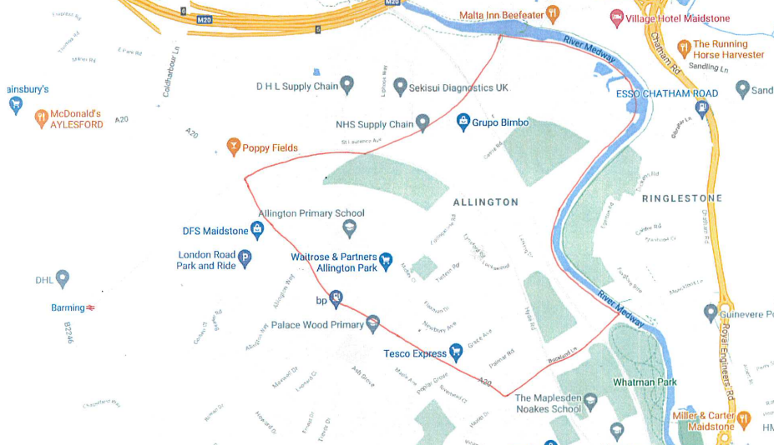
Waiting List
The school holds a waiting list for all year groups. The waiting list will be re-ranked, in line with the published oversubscription criteria, every time a child is added.

Admission of children outside their normal age group
Parents may seek a place for their child outside of their normal age group, for example, if the child has experienced problems such as ill health. In addition, the parents of a summer born child (born from 1 April to 31 August) may choose not to send that child to school until the September following their fifth birthday and may request that they are admitted out of their normal age group – to Reception rather than Year 1.

Parents should submit a request for admission out of the normal age group with evidence supporting the reason for this. They will be required to attend a meeting in school to discuss this in person with the headteacher. They should continue to make an application for their child’s normal age group at the usual time. The decision on their request will be made prior to any offers of admission on National Offer Day. If a request is agreed the application for admission to their normal age group will be withdrawn and a new application must be made the following year. At this point, the oversubscription will be applied as normal.

